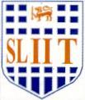
Image Understanding and Processing (OpenCv = Python)

Practical Examination – F
Year 4 Semester 1, 2021

The following figure (A) shows an original image and its processed output image (B). Select an appropriate technique(s) that have been used to obtain it from the original image.

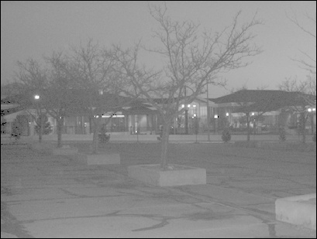
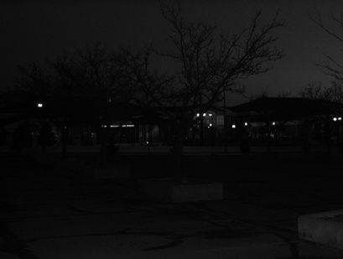

Input Image (A) Output Image (B)

Hint: Use the following transformation function

